Project Design Phase-II
Technology Stack (Architecture & Stack)
Date | 3 October 2026
Team ID | SWTID-2026-9505
Project Name | Implement Client Script & UI Policy (Incident) - ServiceNow
Maximum Marks | 4 Marks
Technical Architecture:
The Deliverable shall include the architectural diagram as below and the information as per the table1 & table 2
Example: Client-side validation of the Incident form in ServiceNow
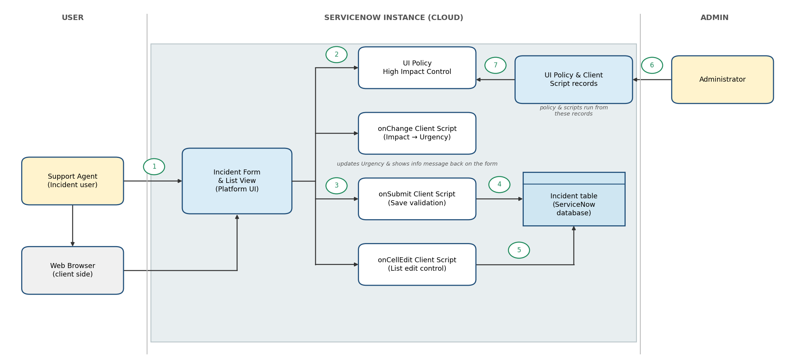

Table-1 : Components & Technologies:
S.No | Component | Description | Technology
1. | User Interface | How the user interacts with the application: the Incident form and list view in the ServiceNow web UI | HTML, CSS, JavaScript (ServiceNow Platform UI in a web browser)
2. | Application Logic-1 | UI Policy (High Impact Control) makes Assigned To mandatory when Impact is 1 - High, with Reverse if false | ServiceNow UI Policy and UI Policy Actions
3. | Application Logic-2 | onChange Client Script sets Urgency to High when Impact is High and shows an info message | JavaScript (GlideForm g_form API)
4. | Application Logic-3 | onSubmit Client Script validates the form and stops incorrect data from being saved | JavaScript (GlideForm g_form API)
5. | Application Logic-4 | onCellEdit Client Script controls Impact and Urgency edits made in the list view | JavaScript (onCellEdit client script)
6. | Database | Stores the Incident records and their field values | ServiceNow platform database (Incident table)
7. | Cloud Database | Database service hosted by the ServiceNow cloud instance | ServiceNow cloud (Now Platform)
8. | File Storage | No separate file storage is needed for this project | Not applicable
9. | External API-1 | No external API is used in this project | Not applicable
10. | External API-2 | No external API is used in this project | Not applicable
11. | Machine Learning Model | No machine learning model is used in this project | Not applicable
12. | Infrastructure (Server / Cloud) | Application deployment on cloud  Local Server Configuration: web browser only, no local server needed  Cloud Server Configuration: ServiceNow instance | ServiceNow cloud instance
Table-2: Application Characteristics:
S.No | Characteristics | Description | Technology
1. | Open-Source Frameworks | No open-source framework is used; the solution is built with ServiceNow's own client-side features | JavaScript with the ServiceNow GlideForm API
2. | Security Implementations | Only users with administrative or configuration access can create or change UI Policies and Client Scripts; access to Incident data is controlled by roles | ServiceNow roles and access controls (ACLs), HTTPS
3. | Scalable Architecture | Multi-tier platform (browser, application, database) managed by ServiceNow; the same rules can be extended to other fields and tables | ServiceNow Now Platform
4. | Availability | The solution runs inside the ServiceNow instance, so it is available whenever the instance is available | ServiceNow cloud hosting
5. | Performance | Client-side scripts and UI Policies run in the browser without extra server calls, so the form stays fast | UI Policy and Client Scripts
References:
https://c4model.com/
https://www.ibm.com/cloud/architecture
https://aws.amazon.com/architecture
https://medium.com/the-internal-startup/how-to-draw-useful-technical-architecture-diagrams-2d20c9fda90d

